Updated Under-ice Licor Assembly Instructions (December 2024)

Everything in the photo below should be included in the box:
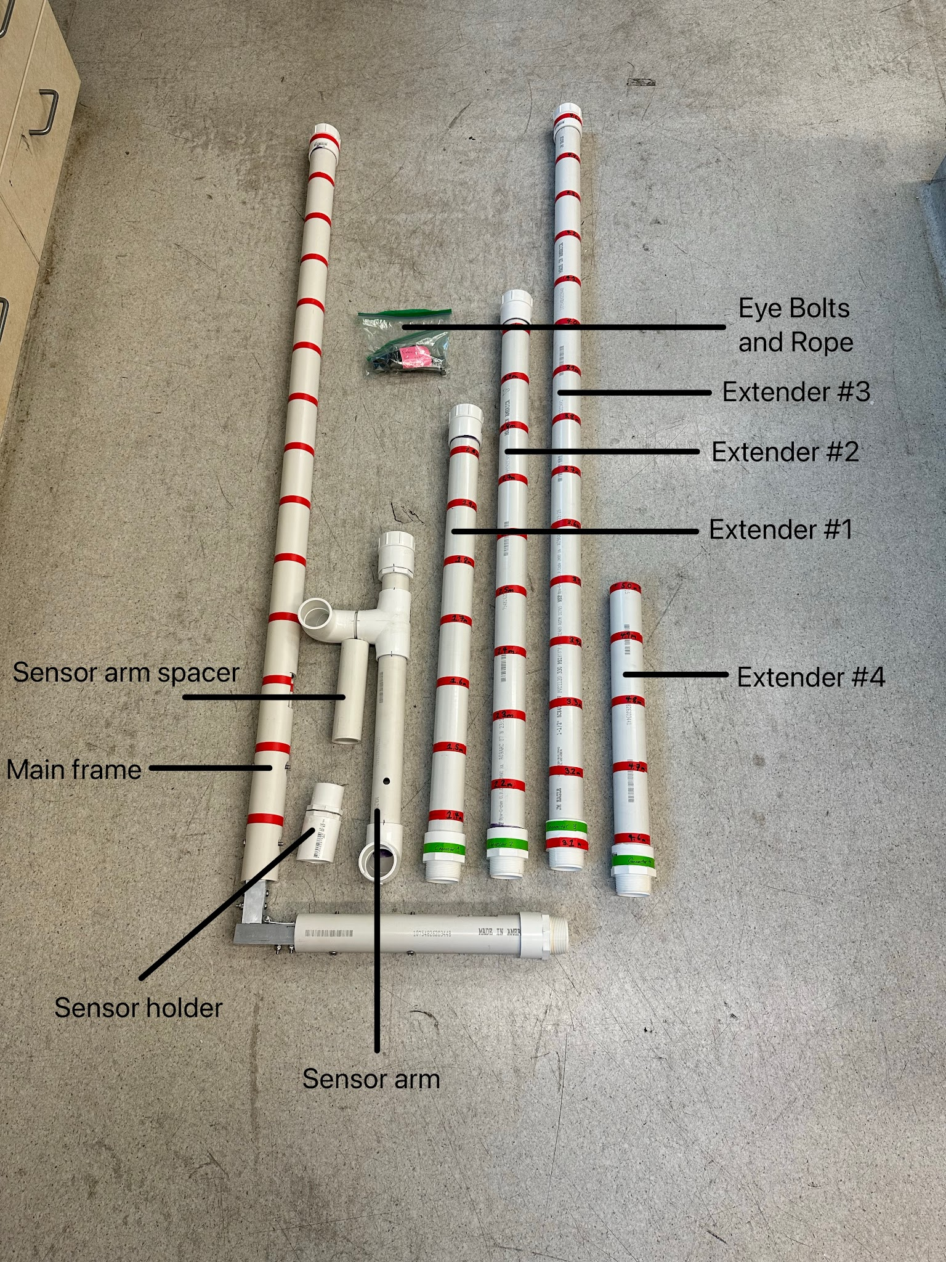

Assembly Steps:

Step 1) Attach the sensor arm to the main frame by screwing the threaded pieces together, making sure that the 90° PVC end piece on the sensor arm is in line with the main frame and pointing upwards.

Step 2) Feed the Li-cor cable through the top of the long arm on the main frame. The cable will then exit the long arm of the main frame close to the hinge where there is a hole cut in the PVC. The cable will then be fed through the cut hole in the short arm of the main frame and be fed all the way through the end of the sensor arm, sticking out of the 90° PVC end piece.

Step 3) Pull about 6 inches of slack in the Li-cor cable through the whole frame. Insert the plastic end of the Li-cor cable through the bottom of the sensor holder, then attach the Li-cor sensor to the cable. Stick the bottom end of the sensor holder into the 90° PVC end piece on the sensor arm and push until snug, then pull all the remaining slack out of the cable. Do the same with the sensor arm spacer in the remaining 90° PVC piece on the sensor arm, pushing in until snug (it doesn’t matter which end sticks up as this is just a spacer).

Step 4) Now it is time to attach the eye bolts/rope. Open the bag with the eye bolts and rope and find the end with the metal washer. The eye bolt on this end of the rope will go through the hole at the top of the long arm on the main frame. Stick the bolt through these holes, with the eye of the bolt facing the same side that the sensor arm is on, and screw on the nylon lock nut to the back until tight. The washer at the end of the rope should be on the bottom side of the eye bolt. Now do the same with the other eye bolt on the end of the sensor arm. There are two extra nuts in the bag if original ones get lost or broken, but are not necessary during assembly.

Step 5) The frame should now be fully assembled and ready to use. The extender pieces are to be used only if need be. You will likely never need all 5 meters of extension, but you have it in case you need to use it. The extenders are to be attached in order (from #1 to #4) as needed and screw on with the attached plastic threads, just like with the sensor arm.

Notes:
- The whole frame (besides the extenders) can stay assembled throughout the winter season. There is no need to disassemble and reassemble during each use. Just make sure to be careful with the Li-cor sensor itself to prevent damage.
- Do everything listed above in reverse order for disassembly

