Materials

PVC

Sensor Arm:
- 1-¼ inch PVC pipe (1ft) (x1)
- 1-¼ inch PVC pipe (4 inches) (x1)
- 1-¼ inch PVC pipe (2.5 inches) (x1)
- 1-¼ inch PVC pipe (5.5 inches) (x1)
- ¾ inch PVC pipe (2.5 inches) (x1) —- for sensor holder
- 1-¼ inch to ¾ inch PVC bushing (x2)
- 1-¼ inch PVC straight coupling (x1)
- 1-¼ inch PVC 90° elbow (x2)
- 1-¼ inch PVC Tee joint (x1)
- 1-¼ inch to 1-½ inch PVC bushing (x1)
- 1-½ inch female threaded adapter (x1)
- PVC primer and cement

Main Frame:
- 1-½ inch PVC pipe (1ft) (x1)
- 1-½ inch PVC pipe (4.5 ft) (x1)
- 1-½ inch female threaded adapter (x1)
- 1-½ inch male threaded adapter (x1)
- PVC primer and cement

Extenders:
- 1-½ inch PVC pipe (lengths determined by desired extension length)
- 1-½ inch female threaded adapter (x1 for each extender)
- 1-½ inch male threaded adapter (x1 for each extender)
- PVC primer and cement

Hardware
- 5/16 x 3-¾ inch stainless steel eye bolt (x2)
- 5/16 inch stainless steel nylon lock nut (x2)
- 1 inch diameter stainless steel washer (x1)
- ¼ inch x 1-½ inch stainless steel machine screws (x4)
- ¼ inch stainless steel nylon lock nut (x4)
- #10-32 x 1-¼ inch stainless steel machine screws (x4)
- #10-32 stainless steel nylon lock nut (x4)
- 3 inch stainless steel strap hinge
- 1 inch diameter aluminum square tube (10 inches long) (x2)

Other Supplies
- 8 ft of paracord
- Licor sensor and cable
- Labeling tape

Directions
Step 1) Start by building the frame hinge
- For this you will need the 10 inch sections of aluminum square tube (x2), the 3 inch strap hinge (x1), the #10-32 machine screws (x4), and the #10-32 lock nuts (x4)
- Line up the two pieces of aluminum square tubing in an L-shape (leaving about a ½ inch of space on the backside of the bottom square tube from the outside edge) and put the strap hinge in place so you can mark holes for drilling:
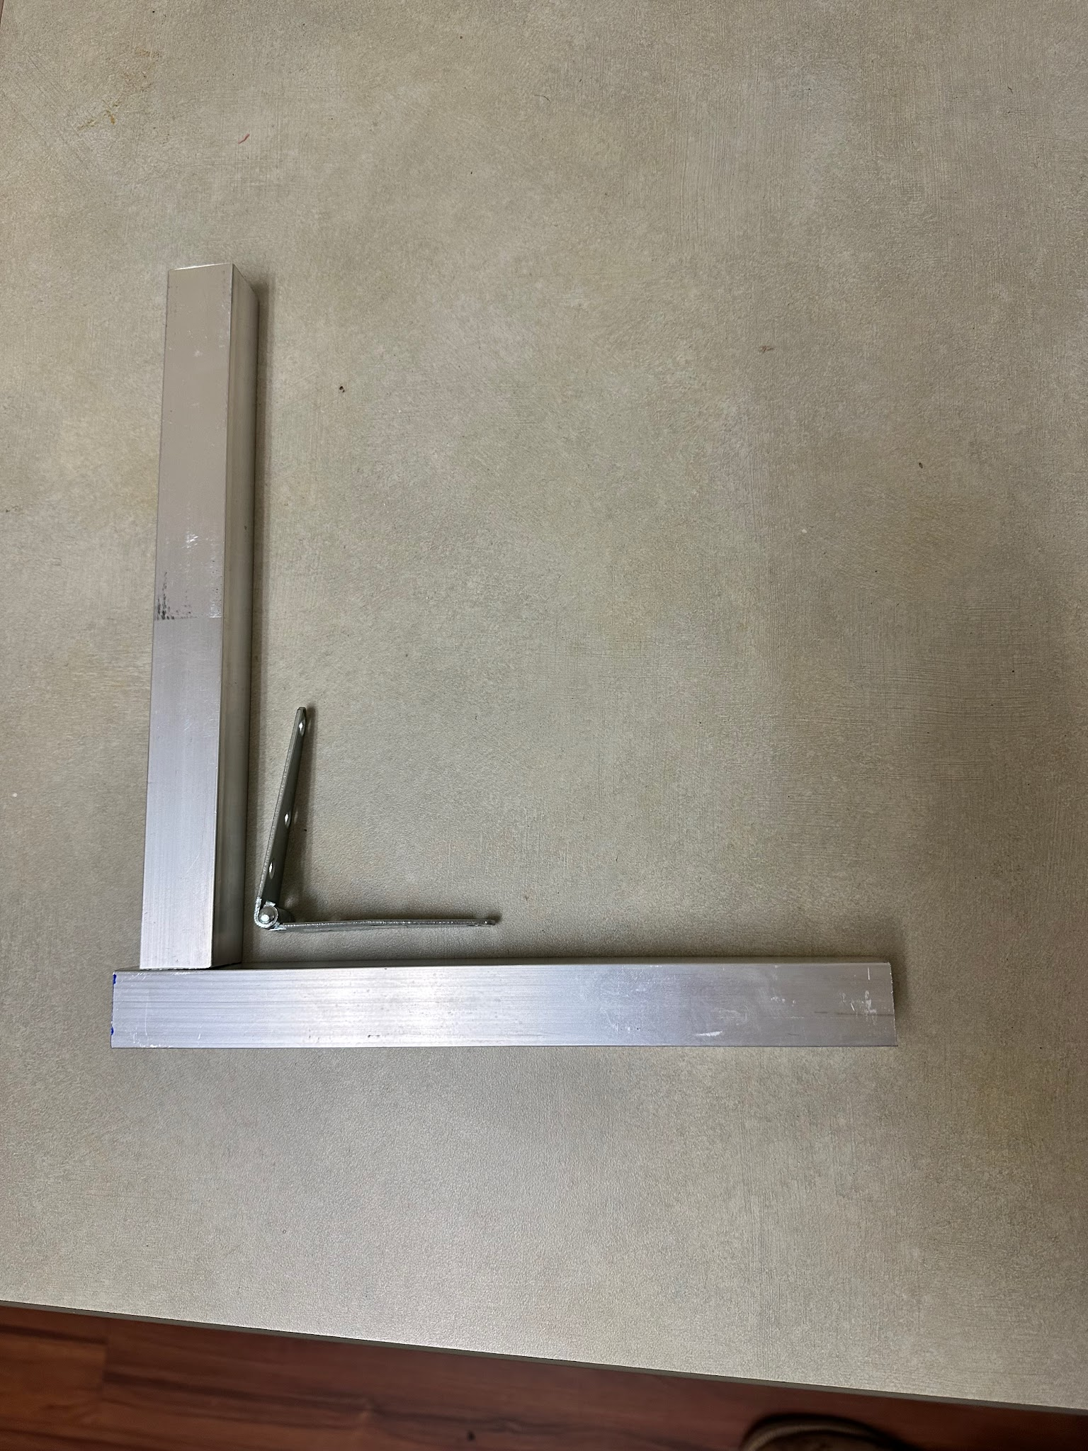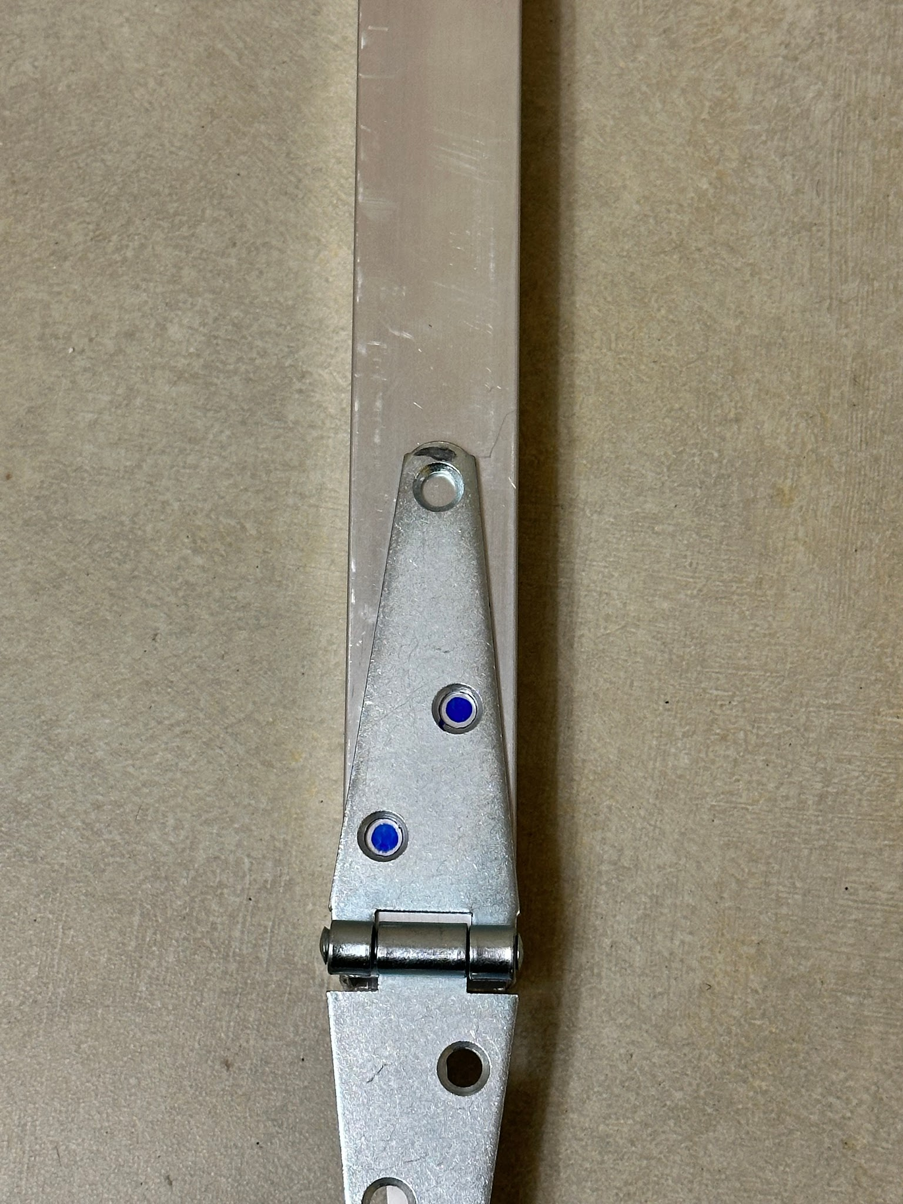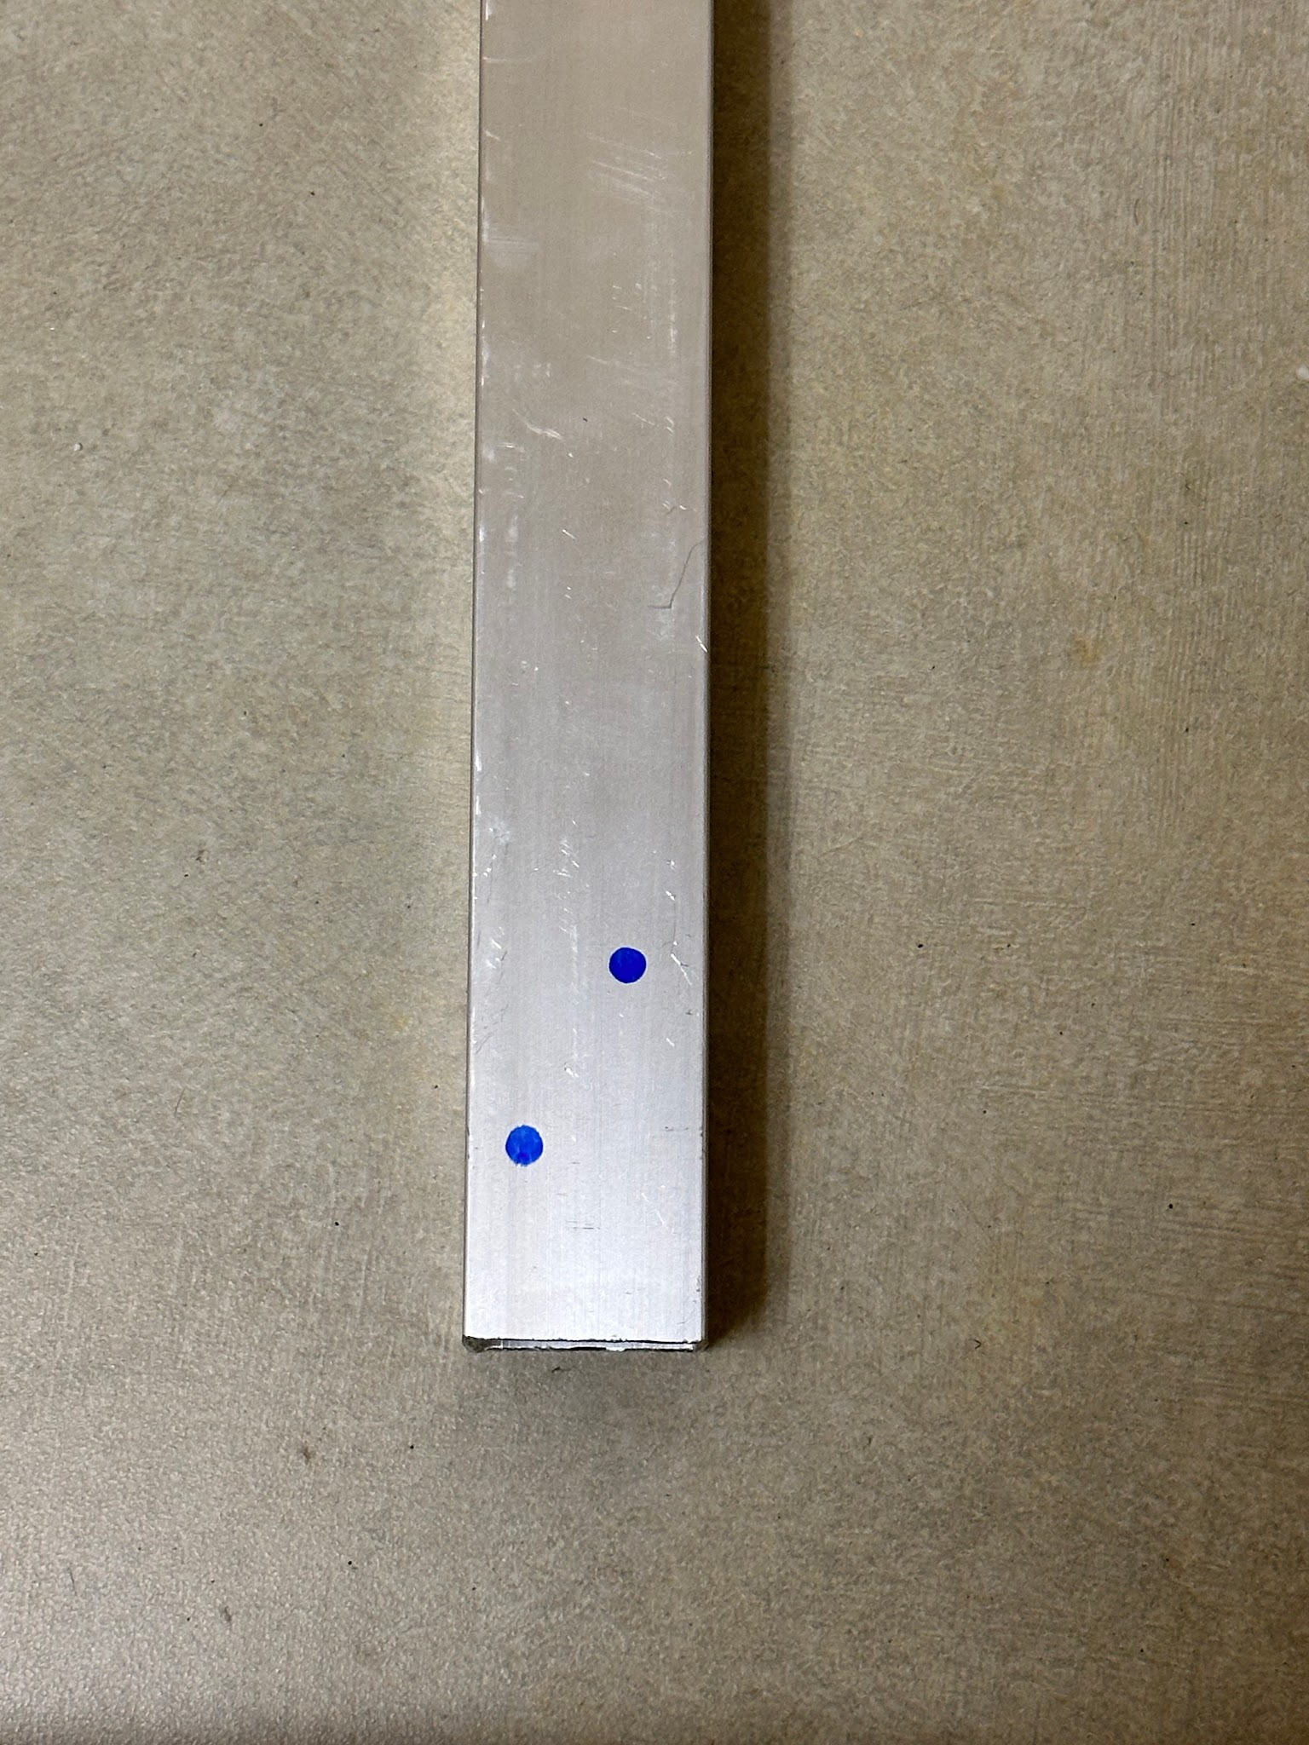
- Once holes are marked on the first piece of square tubing, drill holes all the way through (making sure to drill as straight as possible) and then attach the hinge to the square tubing using the machine screws and lock nuts:
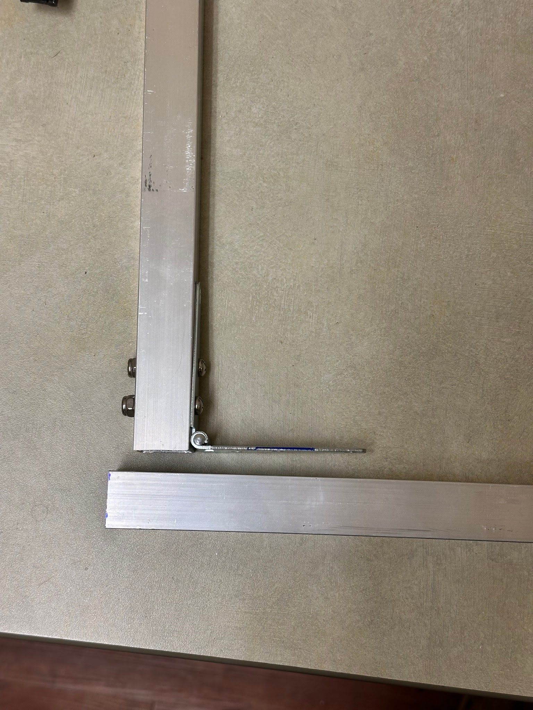
- Then line up the other side of the hinge with the other piece of square tubing (leaving ½ inch of space on the end of the bottom piece of square tubing as seen above), mark holes for the hinge, drill holes, and attach square tubing to the hinge
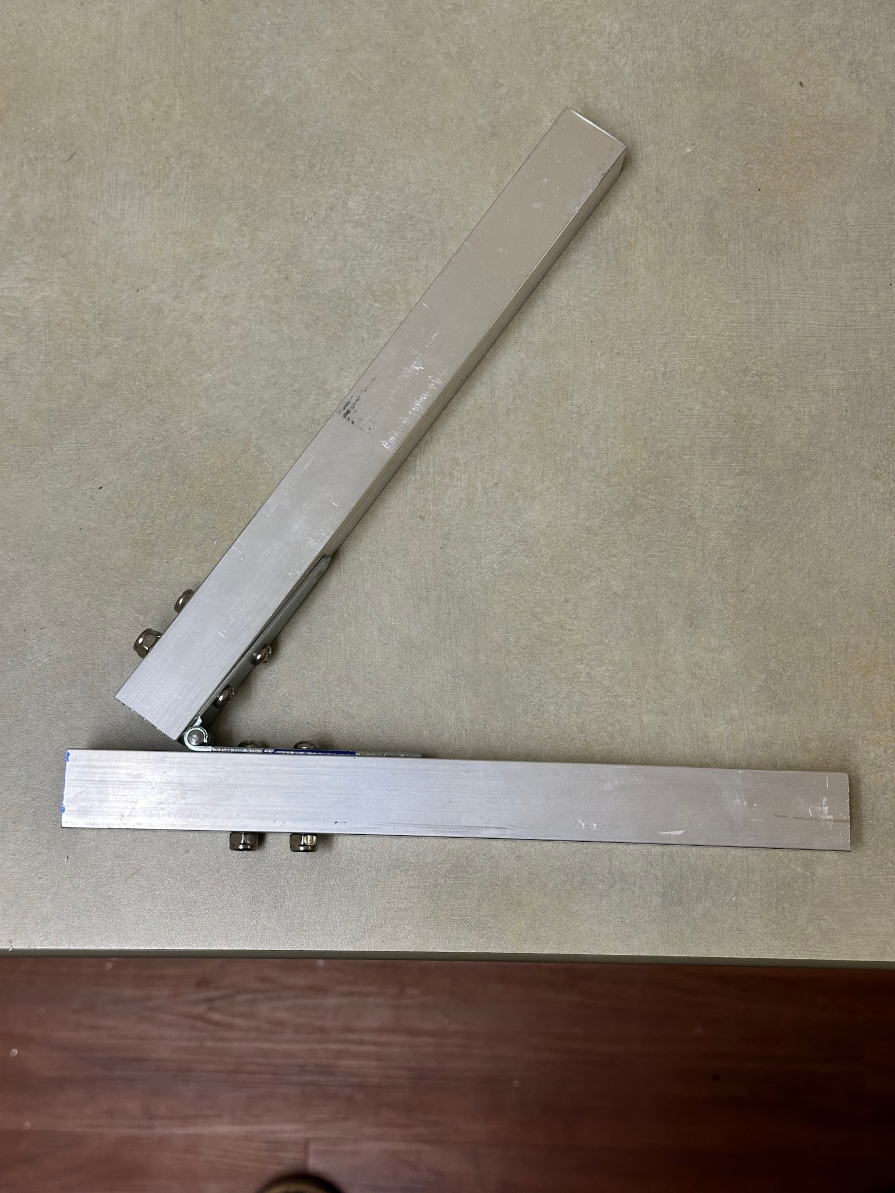
Step 2) Building the sensor holder
- For this, you will need the ¾ inch PVC pipe (2.5 inches) (x1), 1-¼ inch to ¾ inch PVC bushing (x2), and the 1-¼ inch PVC straight coupling (x1)
- The piece of ¾ inch PVC pipe needs to be drilled out in order for the white plastic piece on the end of the Licor cable to be pushed through and screwed on to the bottom end of the Licor sensor
- To do this, use a 13/16 inch paddle bit and a drill. The goal is to increase the inside diameter of the pipe by drilling out the inside walls using the paddle bit.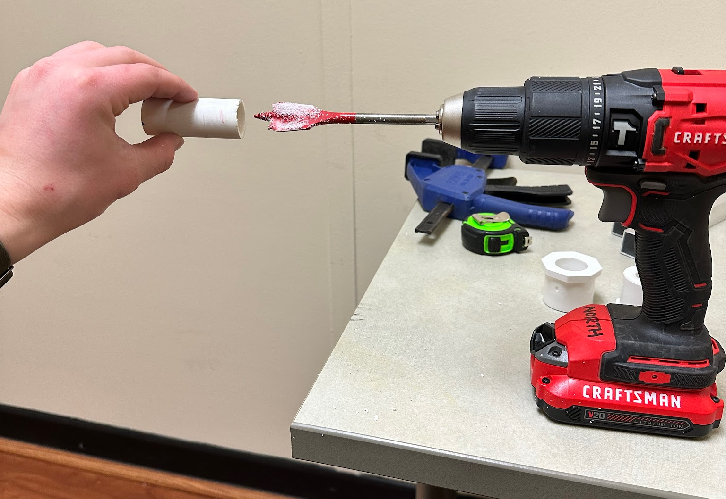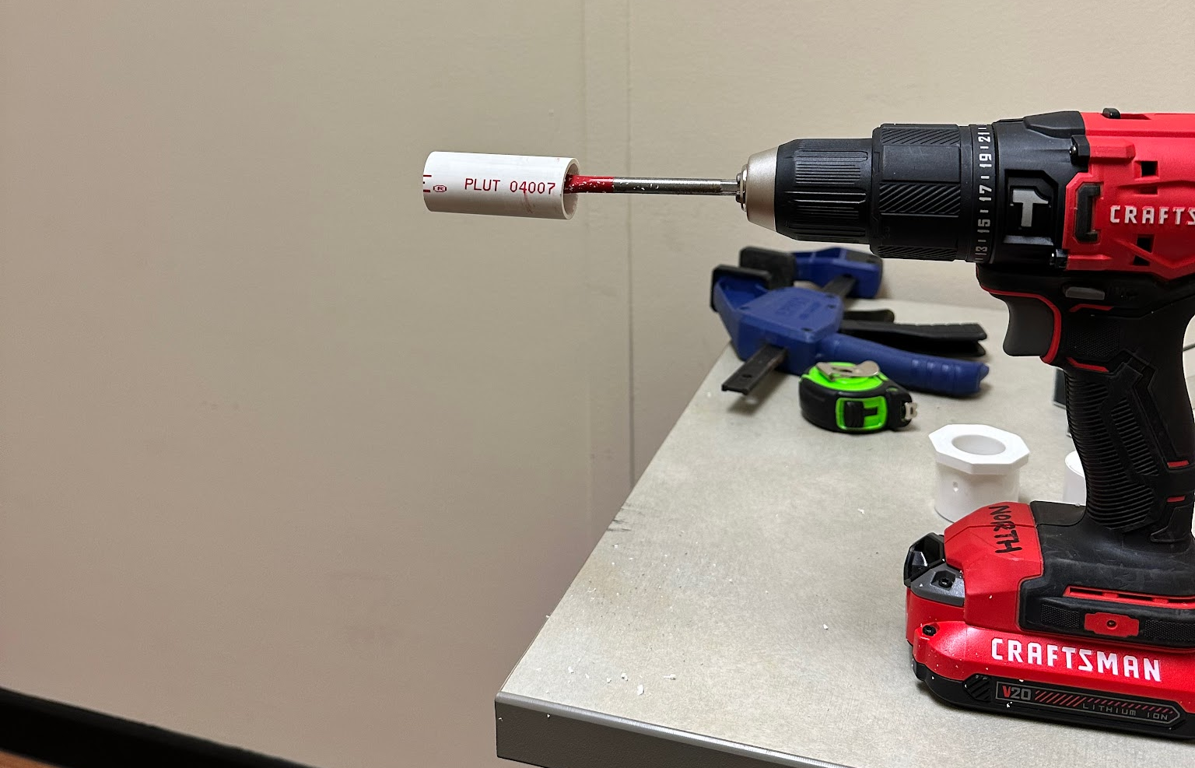
- Shave off plastic from the inside of the pipe until the white threaded piece at the end of the Licor cable slides all the way through with no resistance
- Next, one of the 1-¼ inch to ¾ inch PVC bushings needs to be drilled out to allow for the ¾ inch PVC pipe to slide all the way through. There is a stopper on the bushing about 1 inch in that prevents a ¾ inch pipe from sliding all the way through. This is the part that needs to be drilled out
- To do this, use a 1-⅛ inch paddle bit and drill downwards from the top side of the bushing
- Then use a rounded file to clean up the sides and smooth everything out.
- Once the first bushing is drilled out, push the ¾ inch PVC pipe all the way through the bushing so that just a little bit (<¼ inch) is sticking out of the top. On the bottom side, you can slide the other bushing onto the ¾ inch PVC pipe. The final piece should look like this:
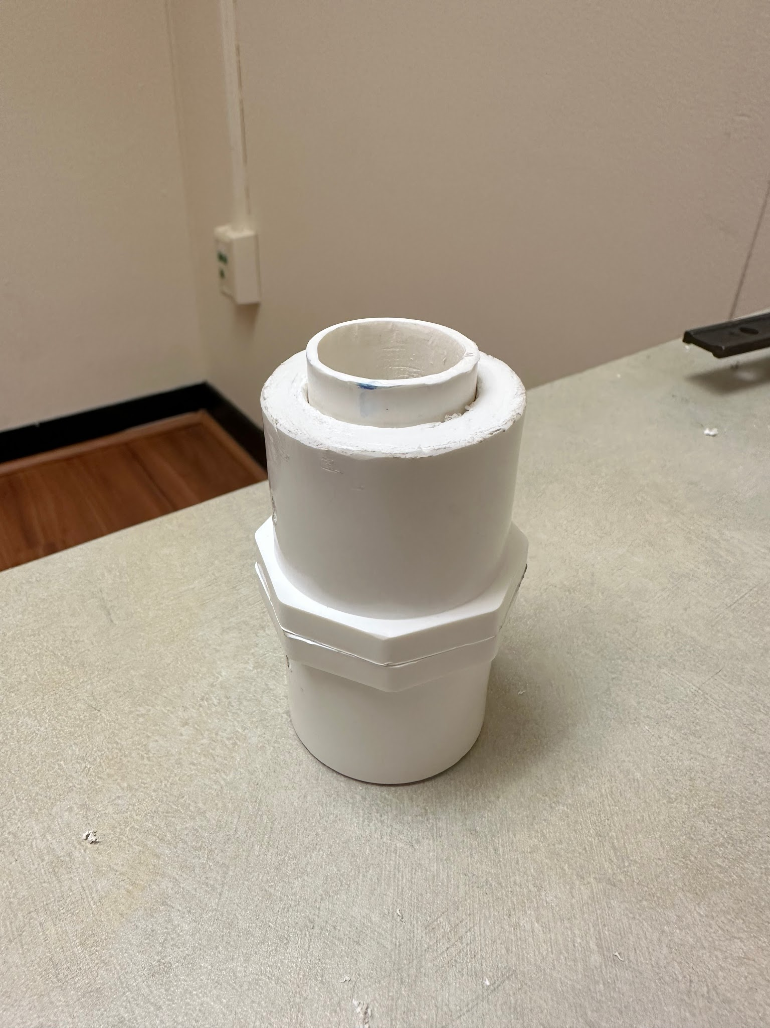
- The 1-¼ inch PVC straight coupling will then be slid over the top of the piece above to protect the sensor once it is in place. For now leave, don’t attach the straight coupling until you have made sure that the sensor will fit into the main part of the sensor holder

Step 3) Building the sensor arm
- For the sensor arm, you will need 1-¼ inch PVC pipe (1ft) (x1), 1-¼ inch PVC pipe (4 inches) (x1), 1-¼ inch PVC pipe (2.5 inches) (x1), 1-¼ inch PVC 90° elbow (x2), 1-¼ inch PVC Tee joint (x1), 1-½ inch female threaded adapter (x1), and 1-¼ inch to 1-½ inch PVC bushing (x1).
- Make sure all the pieces fit together properly like this:
- 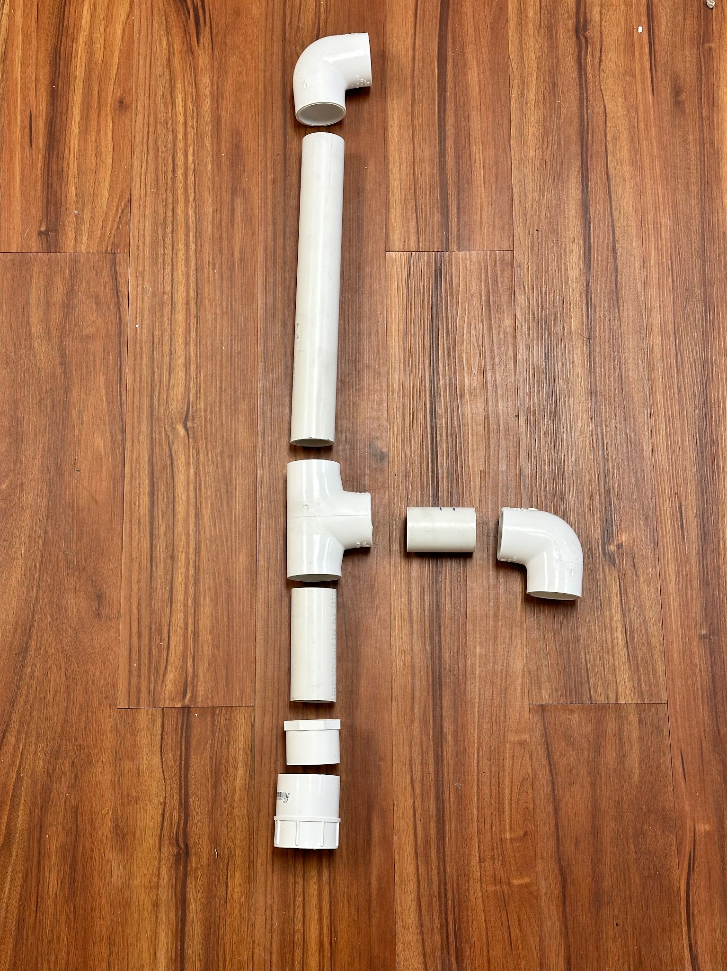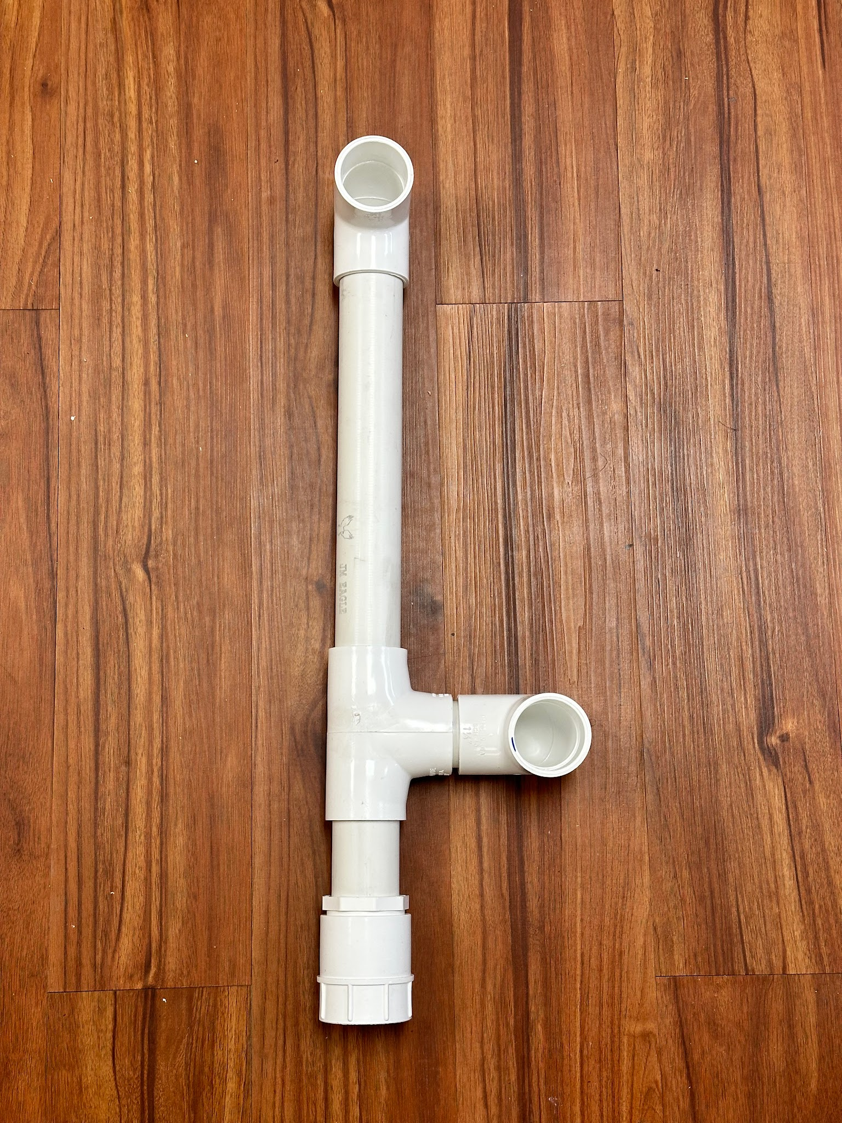
- Finally, make sure the 90° elbows are exactly perpendicular to the Tee joint, then the PVC can be primed and glued.
- Here is the proper way to use PVC primer and glue:
  - https://www.youtube.com/watch?v=x4uKjHgg0oc

Step 4) Building the main frame
- For the main frame, you will need 1-½ inch PVC pipe (1ft) (x1), 1-½ inch PVC pipe (4.5 ft) (x1), 1-½ inch female threaded adapter (x1), 1-½ inch male threaded adapter (x1), ¼ inch x 1-½ inch stainless steel machine screws (x4), ¼ inch stainless steel nylon lock nut (x4), and the frame hinge that was built in step 1.
- Start by inserting the bottom part of the frame hinge into the 1 foot section of 1-½ inch PVC until the PVC reaches the lock nuts on the under-side of the frame hinge. Mark a line on the frame hinge where the end of the PVC sits, then remove the PVC.
- 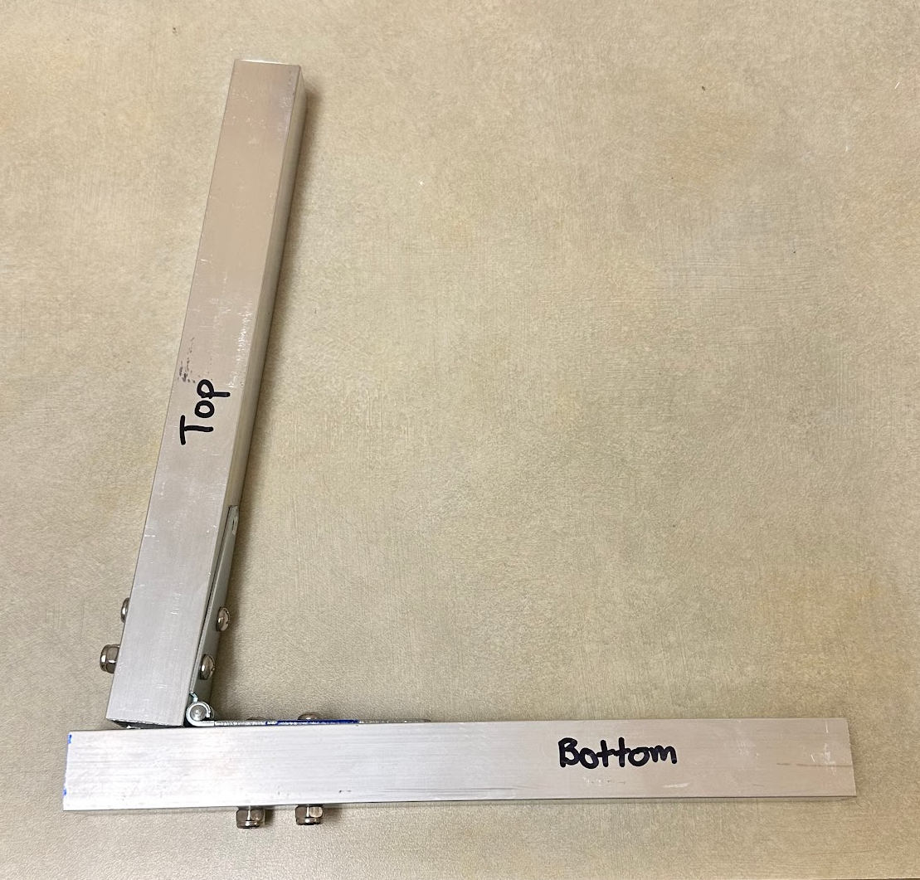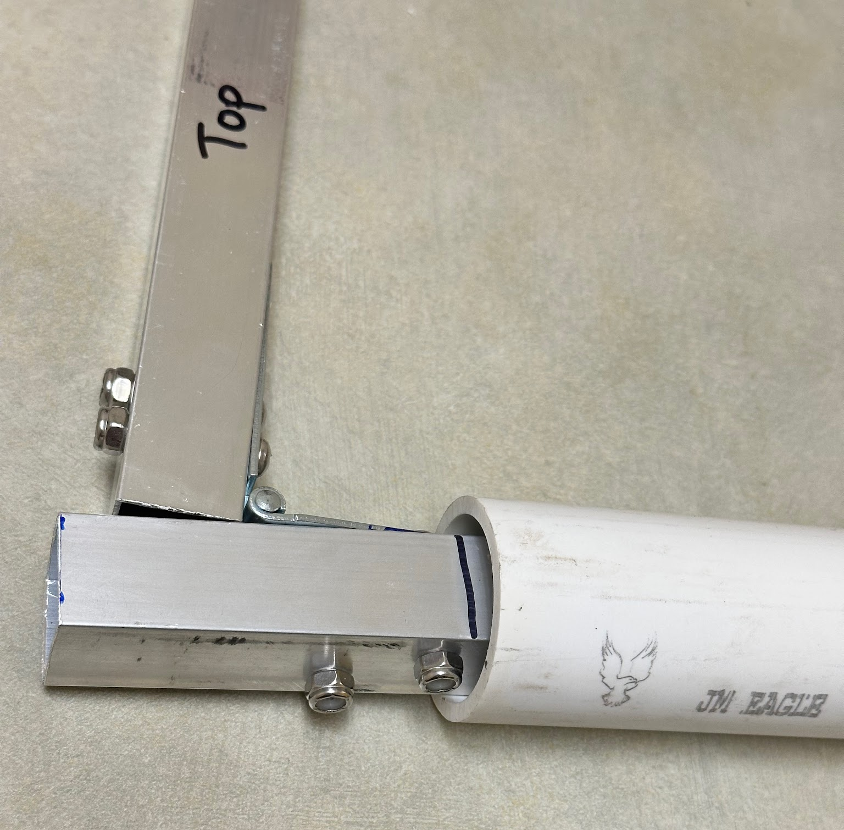
- Now, mark holes on the bottom part of the frame hinge at 1.5 and 4.5 inches and make sure holes are marked on the center of the aluminum tube.
- 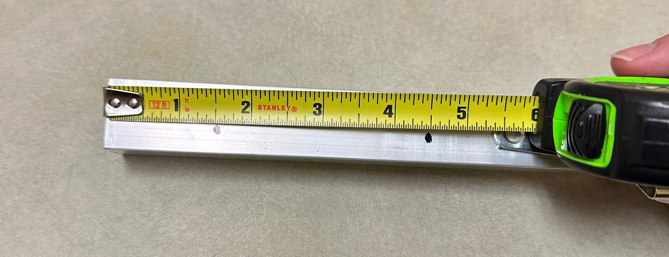
- Then, measure the distance of the two holes from the line marked on the aluminum tube and transfer those marks to the PVC.
- 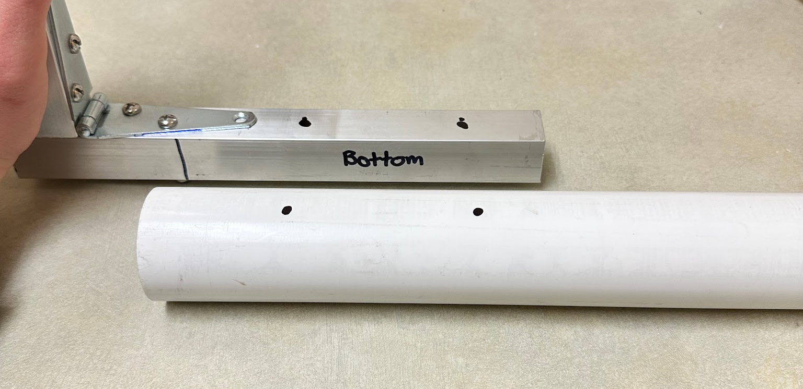
- Once the PVC is marked, drill holes in the PVC using the same 13/16 inch paddle bit from step 2, but only drill holes on the top side of the PVC, not the bottom side yet.
- 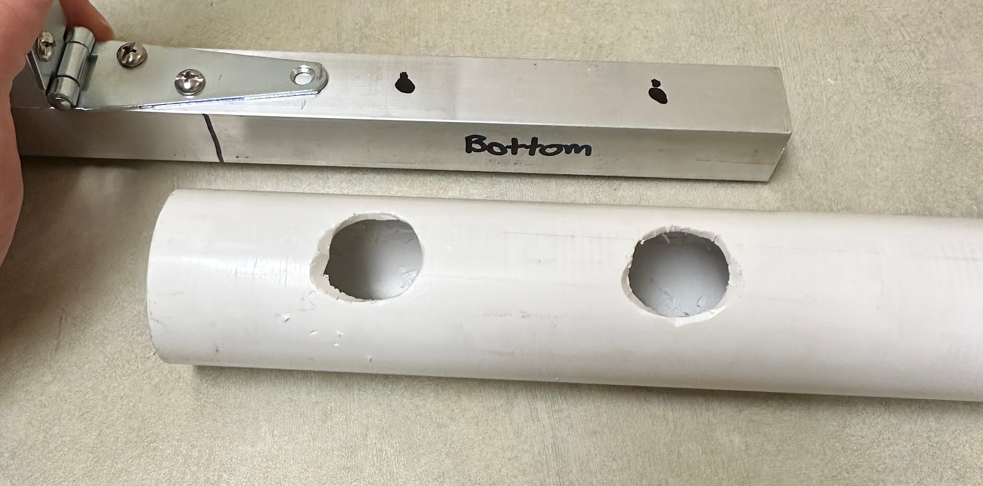
- Next, drill out the holes marked on the aluminum square tubing all the way through the bottom side using a 5/16th inch drill bit, then insert the aluminum tubing back into the PVC and line up the holes in the aluminum tubing with the larger holes in the PVC. Then using the 5/16th inch drill bit, stick the drill bit through the existing holes on the PVC and aluminum tubing and drill through the bottom side of the PVC. Drilling holes in this order will ensure that all of the holes line up correctly.
- 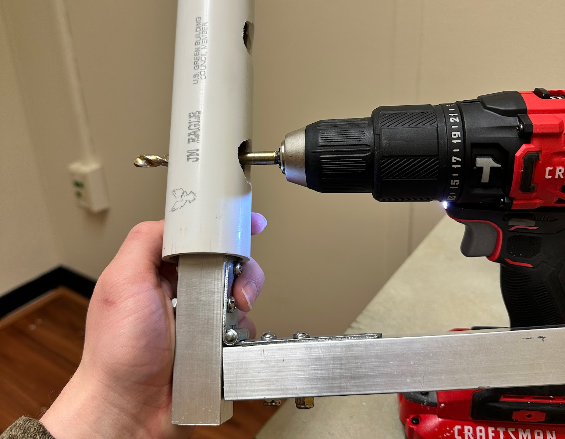
- Once all holes are drilled, bolts can be put through and tightened down to secure the two pieces together.
- To do this, take a ¼ x 1-½ inch machine screw and stick it through all the holes starting from the bottom, then attach a ¼ inch lock nut to the end through the large hole on the PVC. Using a screwdriver and a socket wrench with a 7/16 inch socket, hold the lock nut in place while tightening the machine screw with the screwdriver.
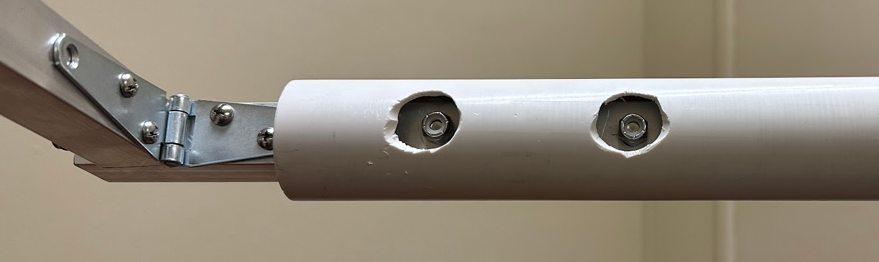
- 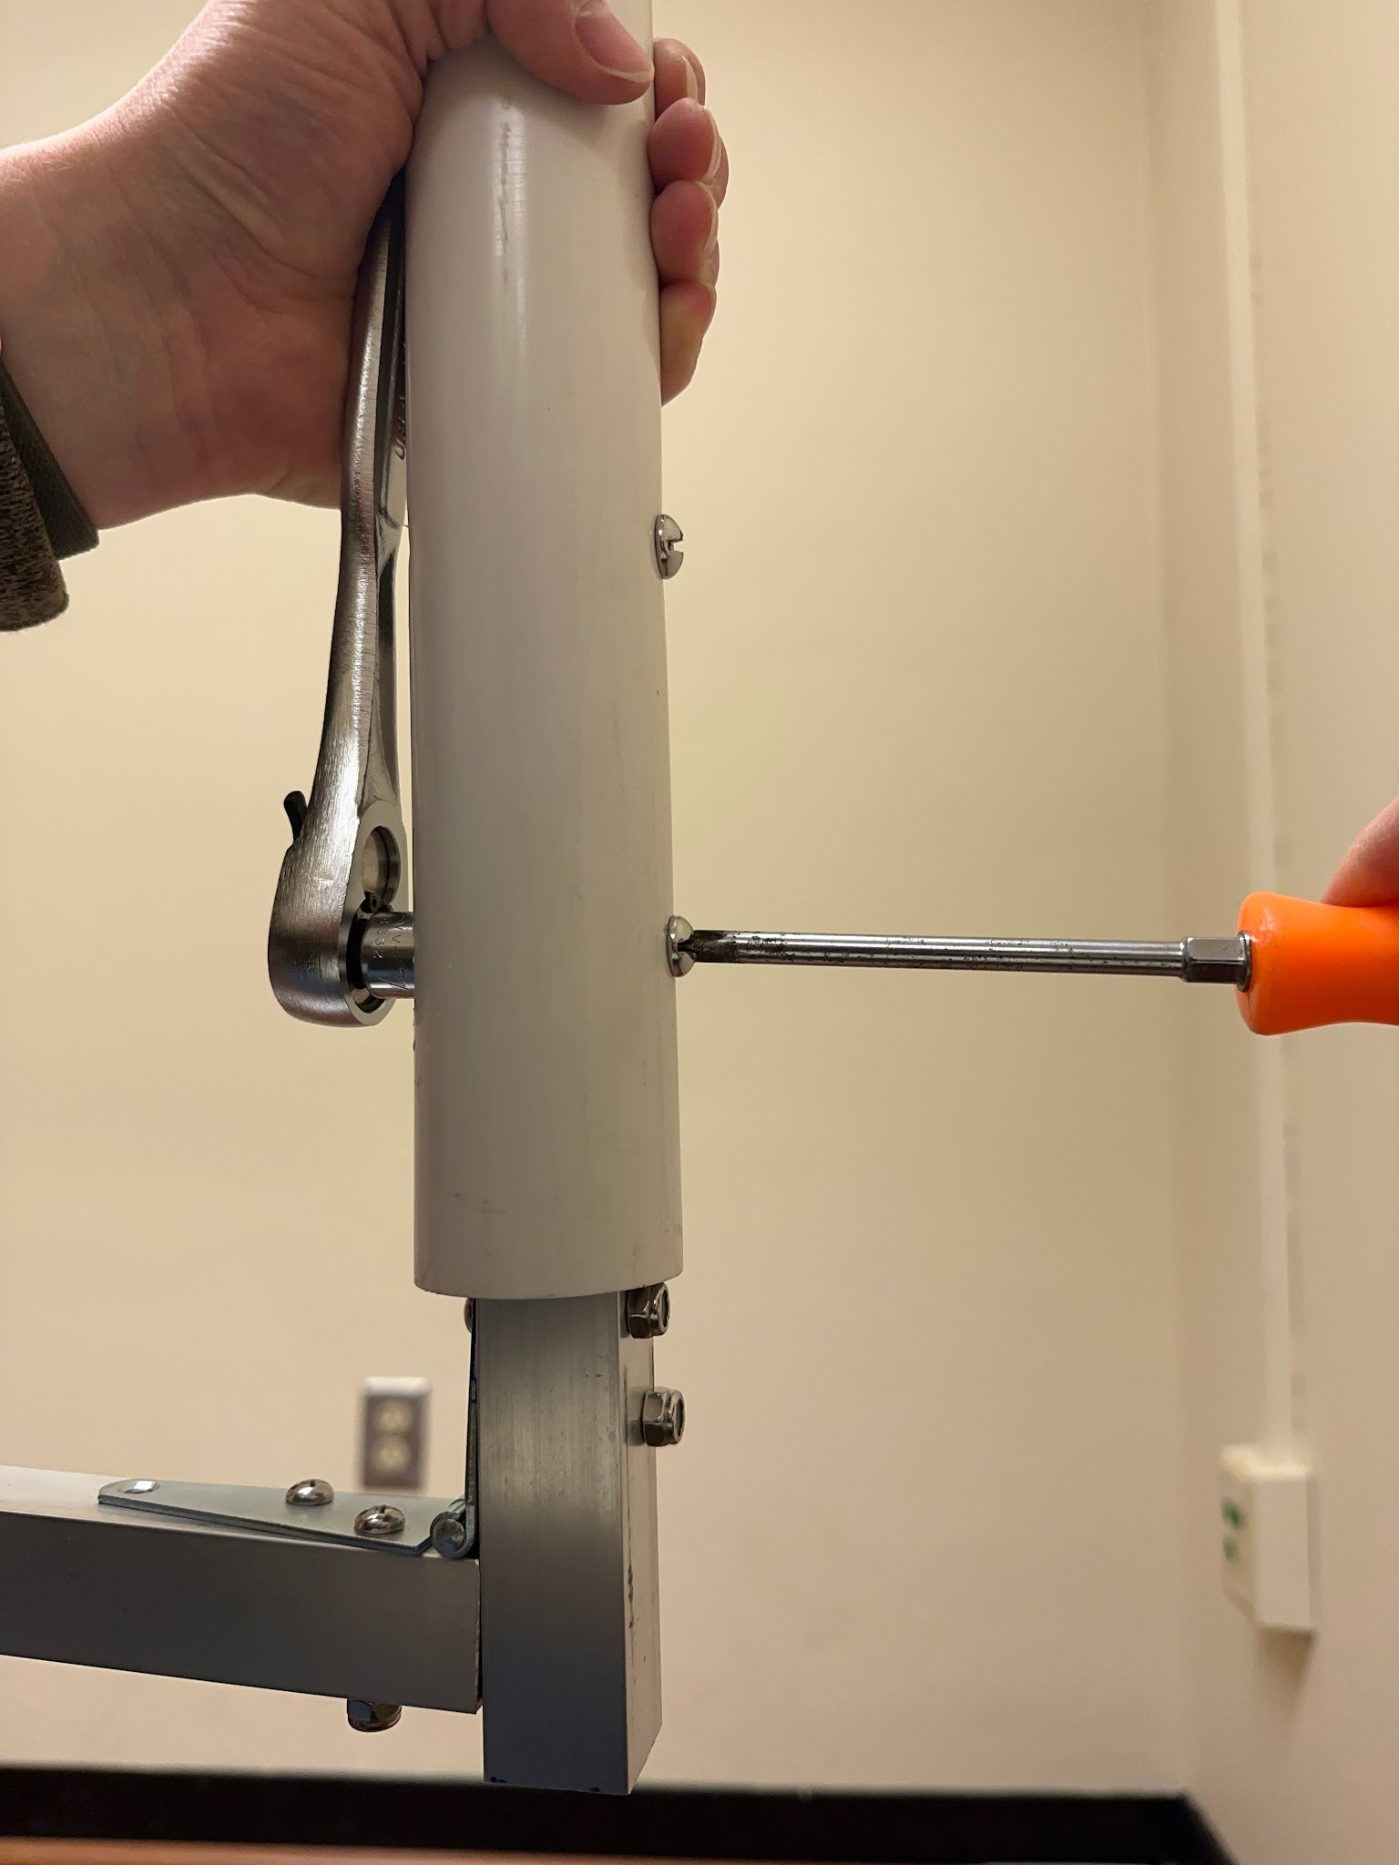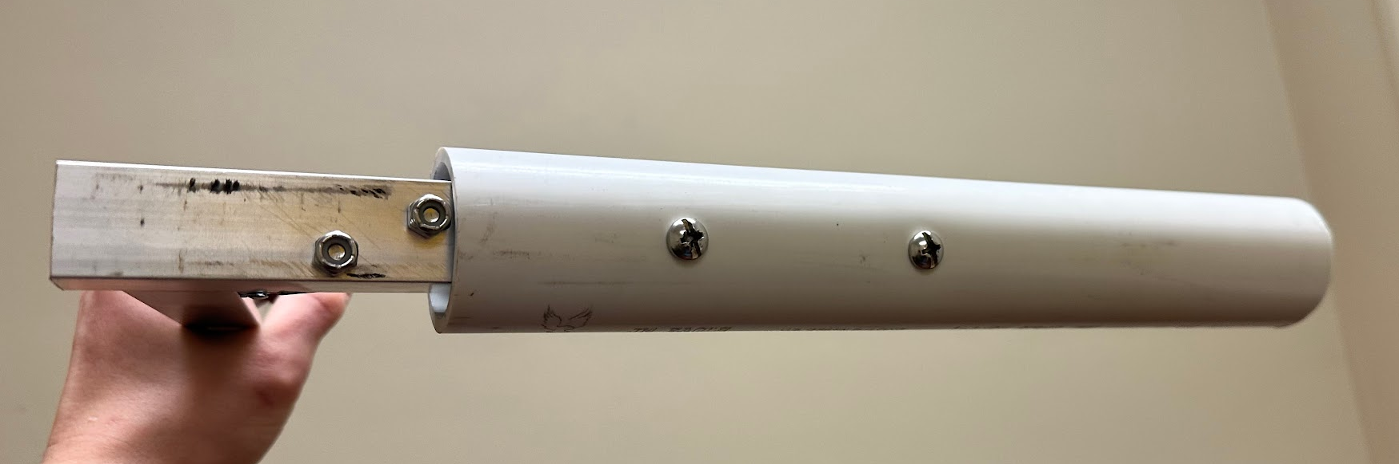
- Then, repeat the whole process on the other side of the hinge using the 4.5 ft piece of PVC.
- The final piece should look like this:
- 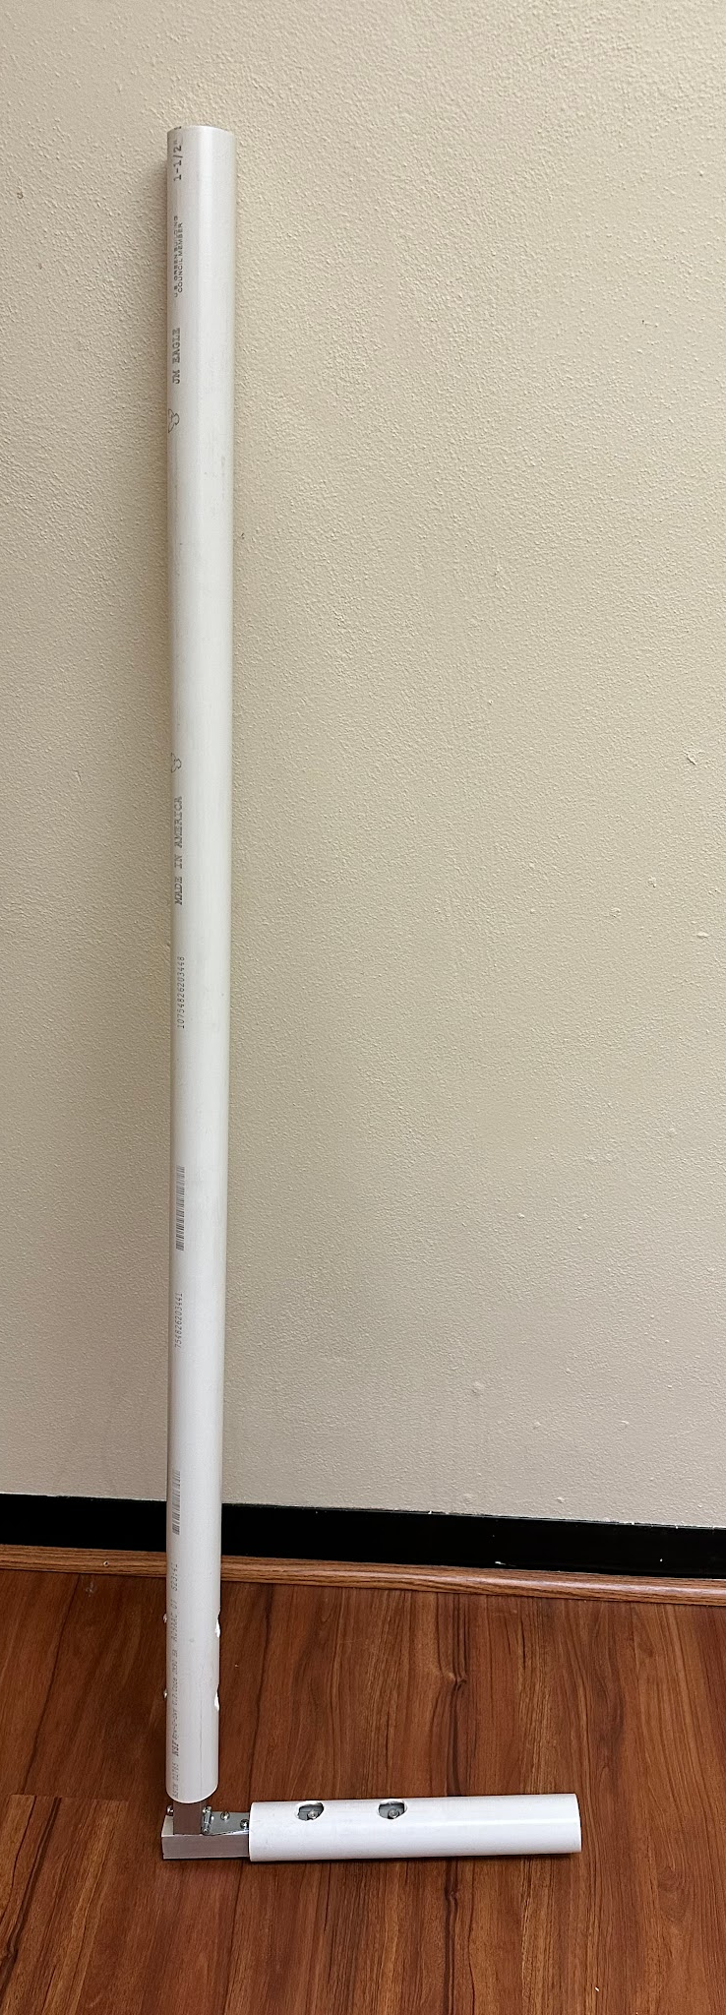
Step 5) Cut Holes for Licor Cable
- For this step you won’t need any materials, just tools.
- You will cut holes in the PVC on both sides of the main frame to allow for the Licor cable to pass through.
- Start by measuring for holes on each side of the main frame. Start at the end of the aluminum tubing and measure 10.5 inches then mark this point.
  - This marked spot should be 0.5 inches past the end of the aluminum tubing on the inside of the PVC.
- Do this on both sides.
- 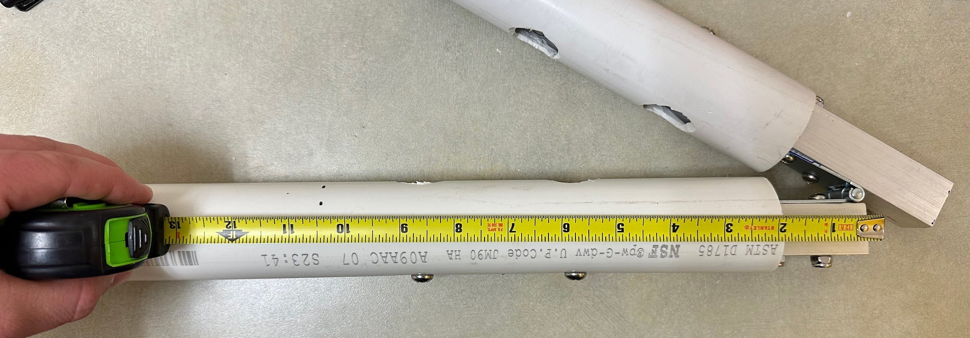
- Once these lines are marked, you may want to detach the long section of PVC from the frame to make it easier to work with.
- Then, using that mark, draw a square 1 inch wide and 2.5 inches tall. This rectangle will be cut out to allow the cable to pass through. Make sure this rectangle is marked on the top and front side of the PVC (the same sides that the large holes for the lock nuts are).
- 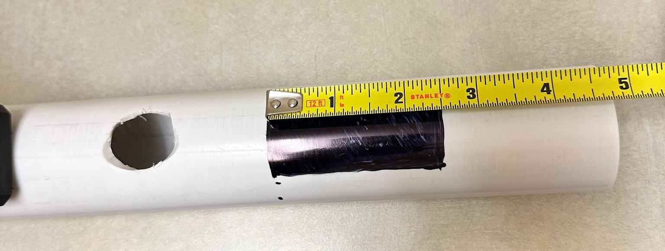
- You may want to use a file to smooth out any sharp edges to prevent damage to the Licor cable
- Once completed, it should look like this:
- 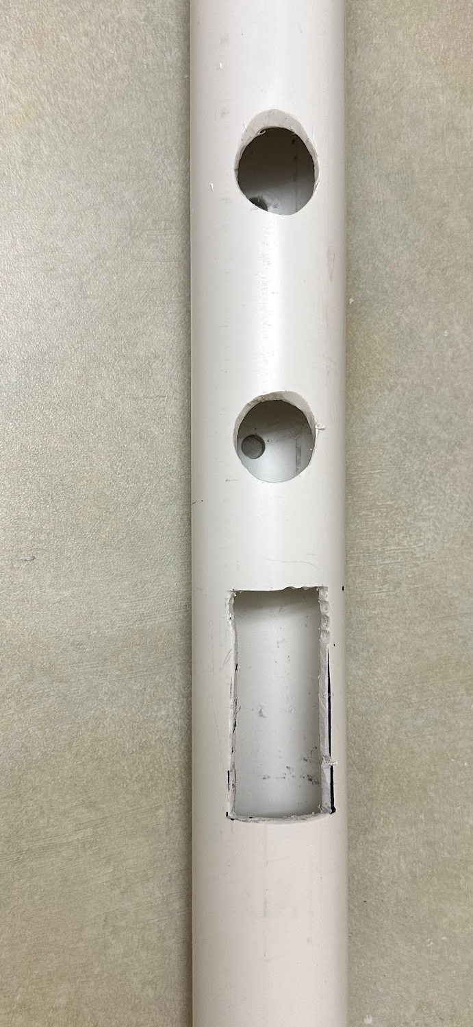
- Then, repeat this on the other piece of PVC
Step 6) Drill Holes for Eye Bolts
- For this step you won’t need any materials, just tools.
- At the top end of the 4.5 ft piece of PVC measure 4 inches from the edge and mark a point on the same side as the rest of the hole on the other end.
- On the Sensor arm, measure and mark a point 2 inches from the edge of the PVC 90° elbow.
- Drill a hole at both marked points all the way through both side of the PVC using a ⅜ in drill bit.
- Then attach the eye bolts to make sure they fit (make sure to use lock nuts instead of the nuts that come with the eye bolt)
- Once completed, it should look like this:
- 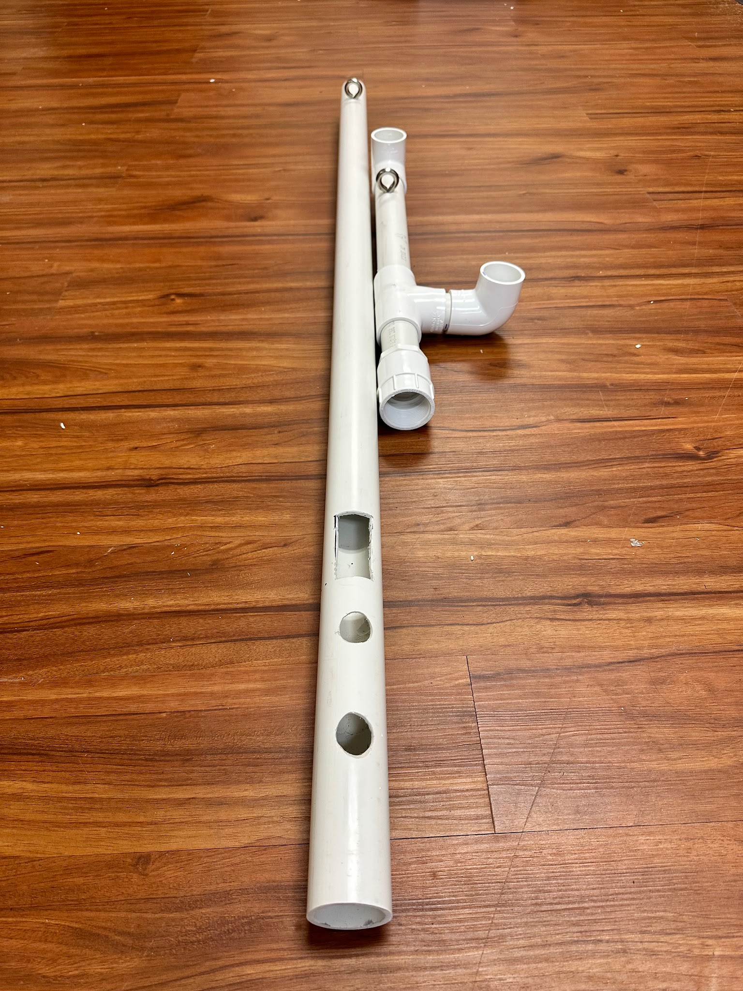
- Then remove eye bolts and set to the side until everything else is completed

Step 7) Attach Threaded Adapters to Main Frame
- Start by screwing one of the male threaded adapters into the female threaded adapter on the end of the sensor arm. The PVC threaded fittings tend to get stuck together easily so when working with them, screw fittings together until just snug, then give them one more ⅛ turn. If you screw them together too tightly, they will not come undone, which defeats the purpose of the removable threaded pieces.
- Then insert the short arm of the main frame into the threaded adapter, making sure that the sensor arm lines up directly with the long arm of the main frame
- Once everything is lined up nicely, mark both the short arm of the main frame and the male threaded adapter as shown below:
- 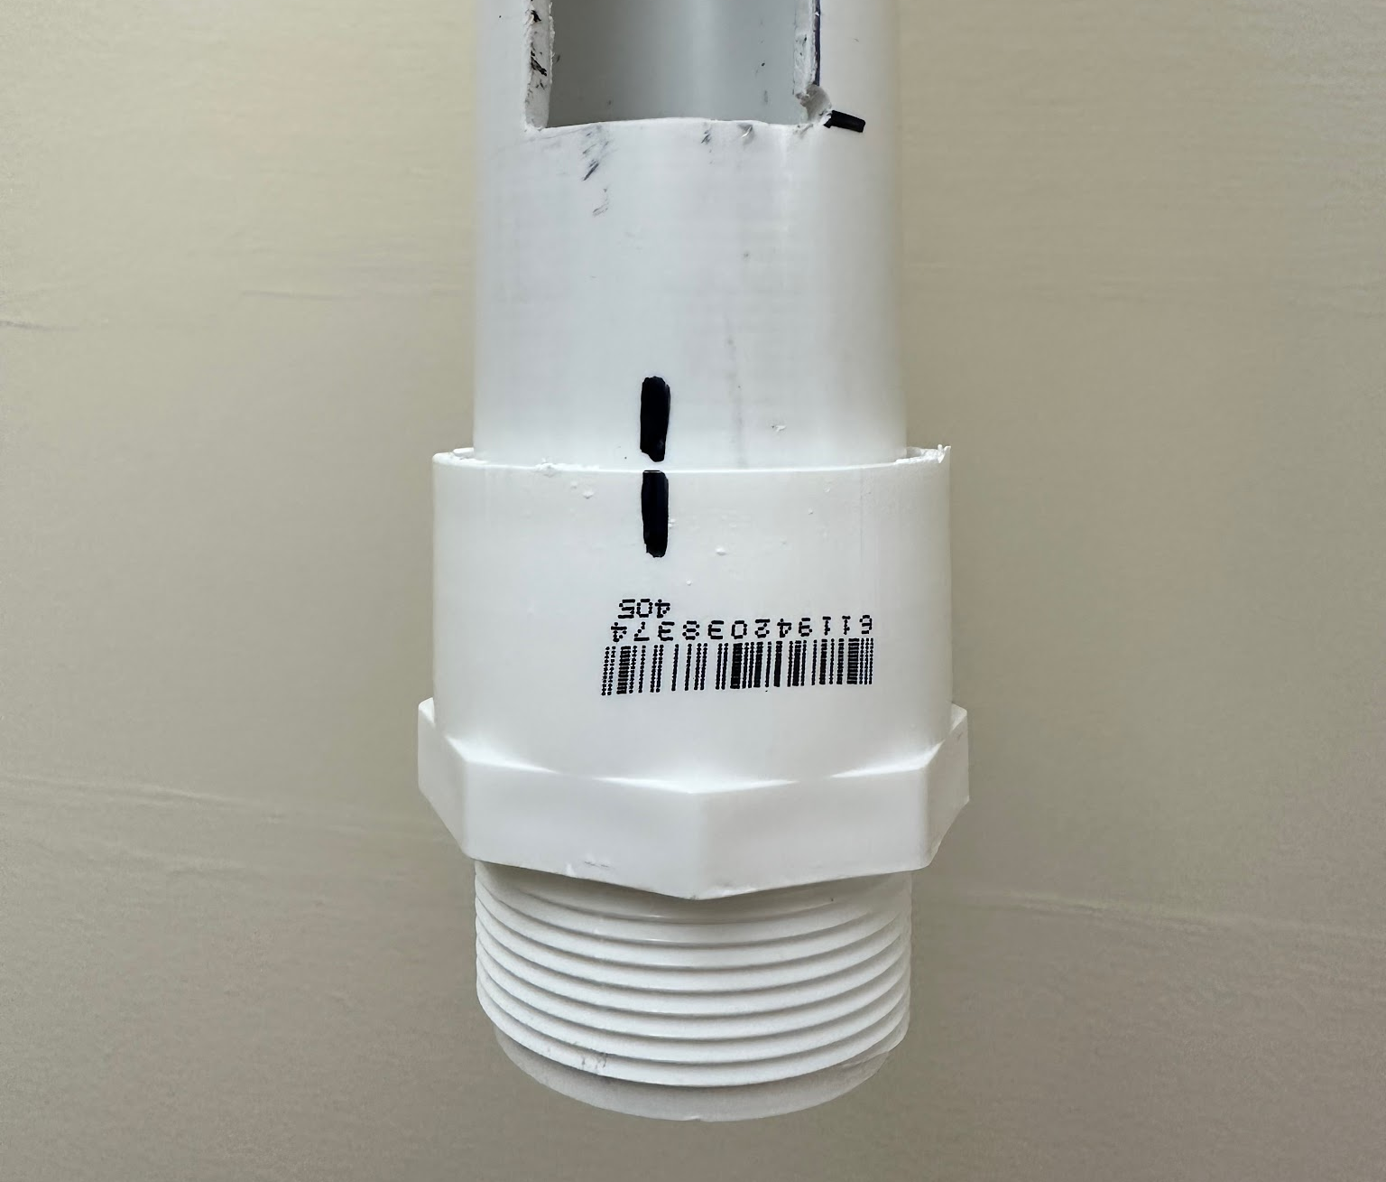
- This will ensure that everything stays lined up when you take things apart to glue.
- Then go ahead and glue these two pieces together, making sure that your marks line up with each other.
- Next, attach (and glue) a female threaded adapter to the end of the long arm on the main frame. The orientation of this threaded adapter is not important right now, since you will line up the orientation when you add the extender on top.

Step 8) Building the Extenders
- Lay a tape measure (meters) on the floor and find the zero point on the main frame. Since the sensor will sit in the sensor holder at the end of the sensor arm, it will be raised by about 5 inches. Find this height and transfer a mark to the lower end of the long arm on the main frame. This will be your starting point (or zero point) for measuring your extender off of, and also for labeling.
- 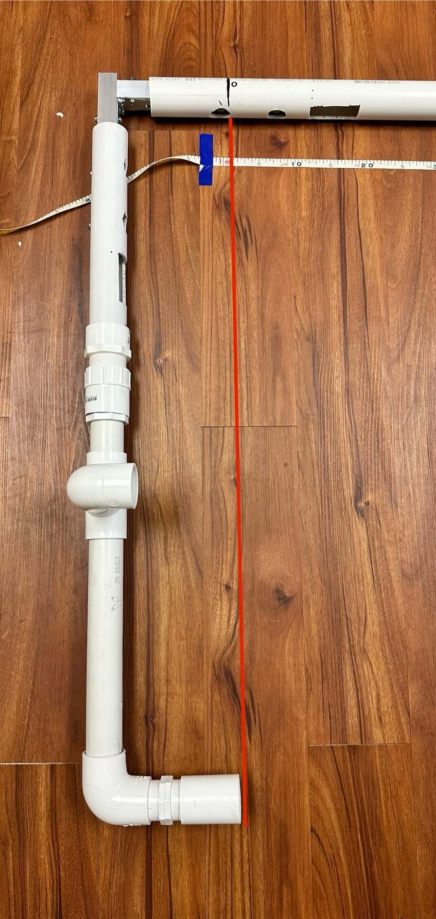
- Now, using that zero point, measure the lengths of 1-½ inch PVC you will need for the extenders.
- The main frame is a little over 1 meter long so the first extension piece will cover the distance to about 2 meters. From there you can make 1 meter sections using the 1-½ inch PVC until you have a full 5 meters in length (including the main frame)
- Make sure to be conscious of the length added by the male and female threaded adapters that will be used to connect each extender piece.
- Now lay the mane frame next to a tape measure (in meters) and mark points every 0.1 meters. Once you get to the end of a section, attach an extender making sure it is not too tight, and continue marking 0.1 meter lines.

Step 9) Labeling Measurement Markings
- This step is very simple. Using the 0.1 meter markings, wrap and label each mark with electrical tape.
- You will also want to label the extenders (Extender #1, Extender #2, etc.), as they will be attached in a certain order.
- 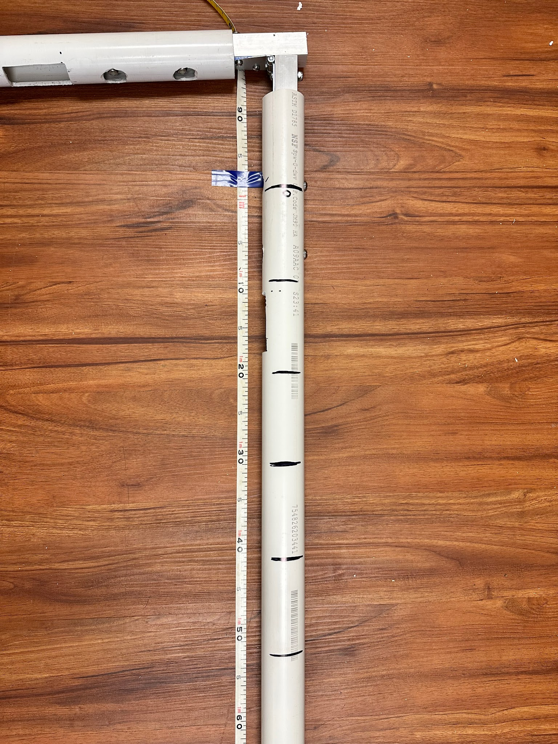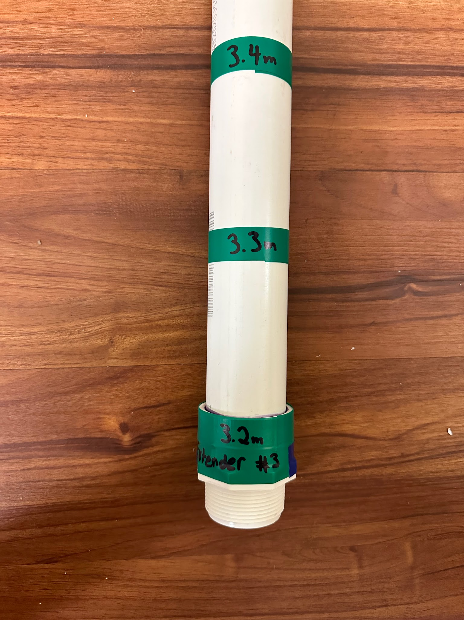

Step 10) Create the “pulley” rope
- For this step you will need the roll of paracord and the 1 inch stainless steel washer, and the stainless steel lock nuts for the eye bolts, as well as a light to burn frayed ends of the paracord.
- Measure out a piece of paracord that is as long at the sensor arm and the main frame combined, as seen below.
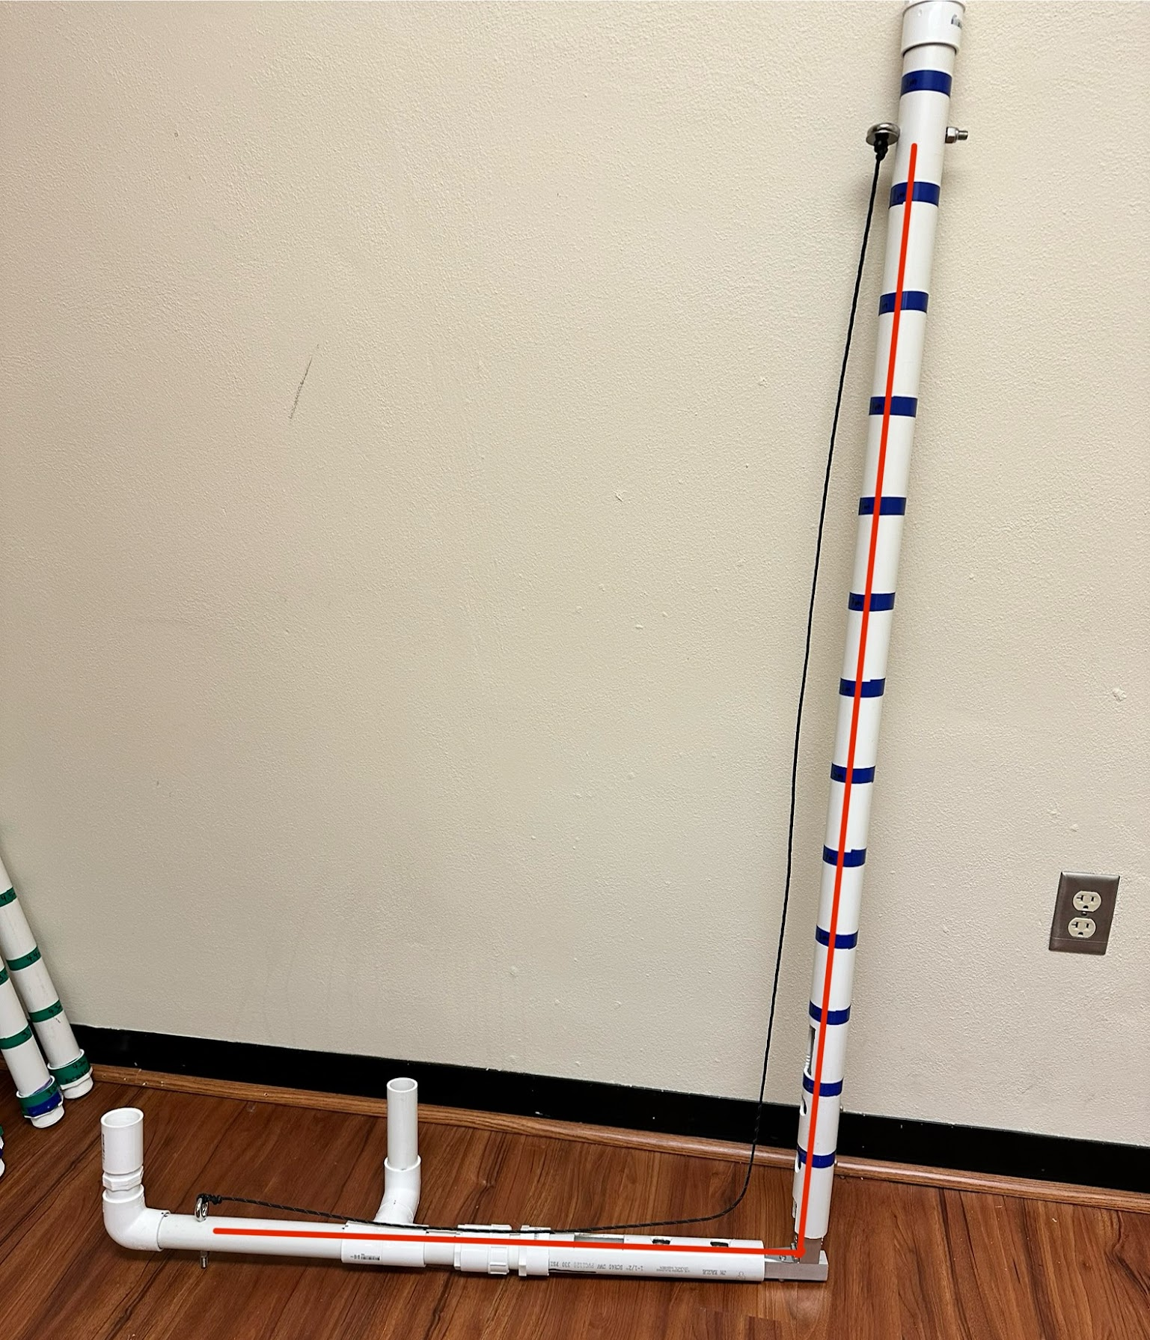
- Then tie a very snug knot onto the eye bolt on the far end of the sensor arm, then feed the other end of the rope through the top side of the other eye bolt.
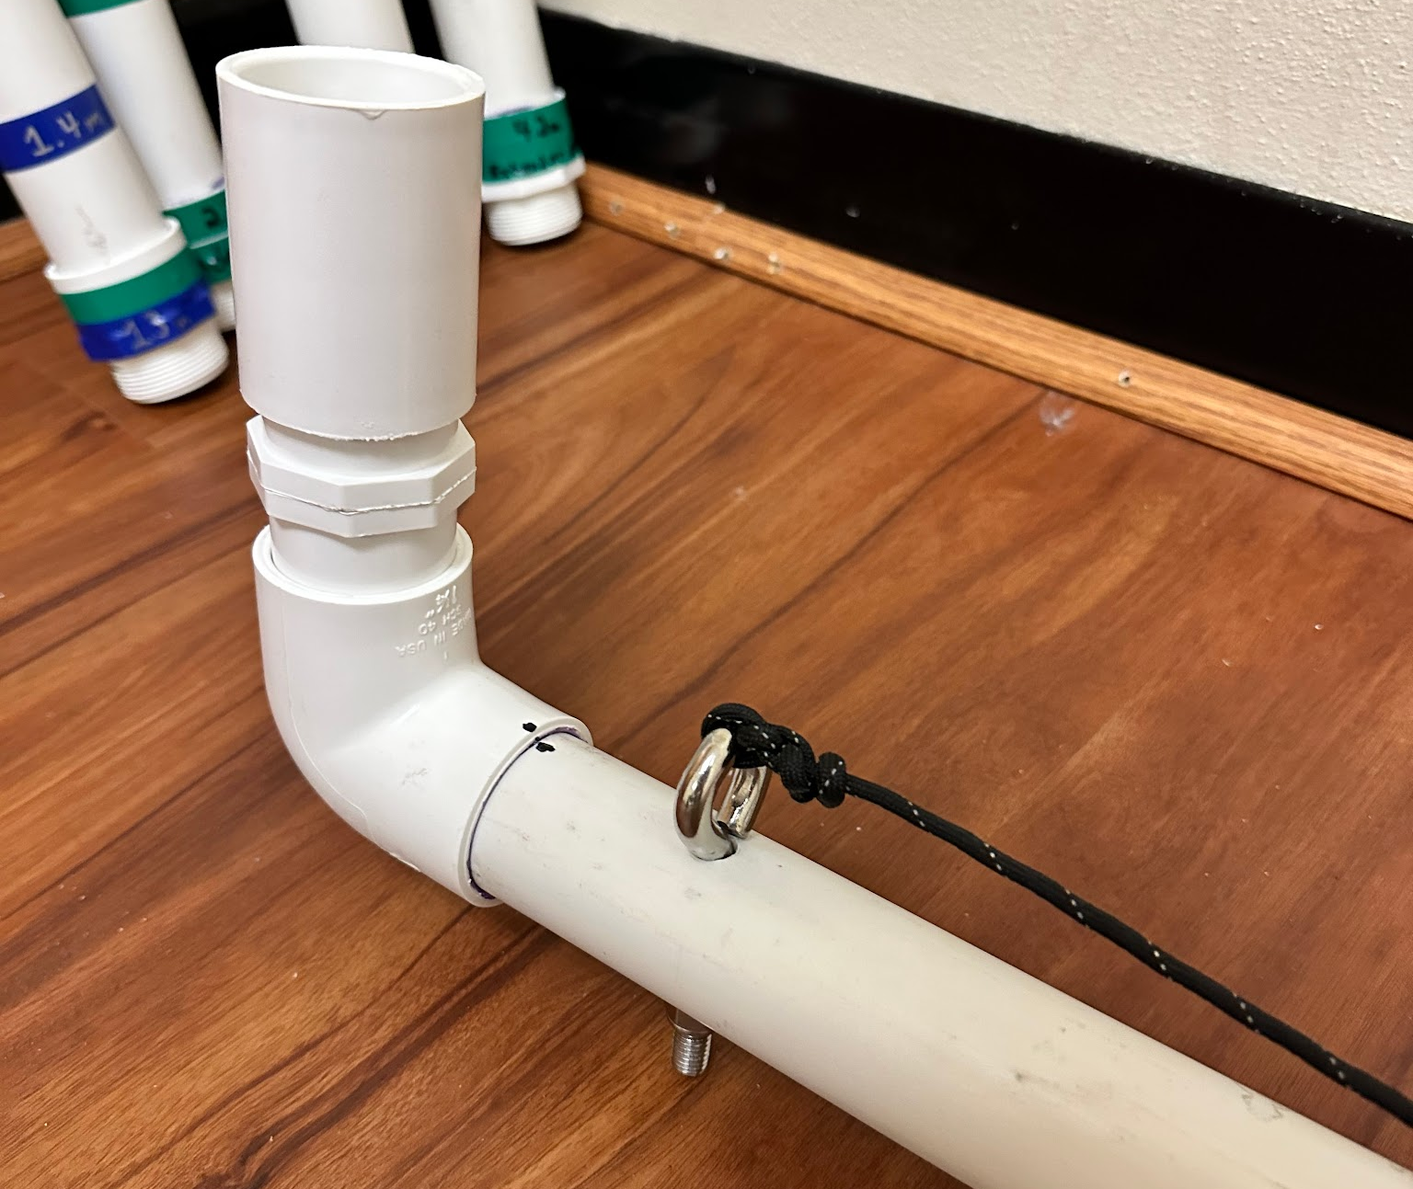
- Now feed the loose end of the paracord through the washer and tie a large knot on the underside of the washer so that the paracord cannot slip back through.
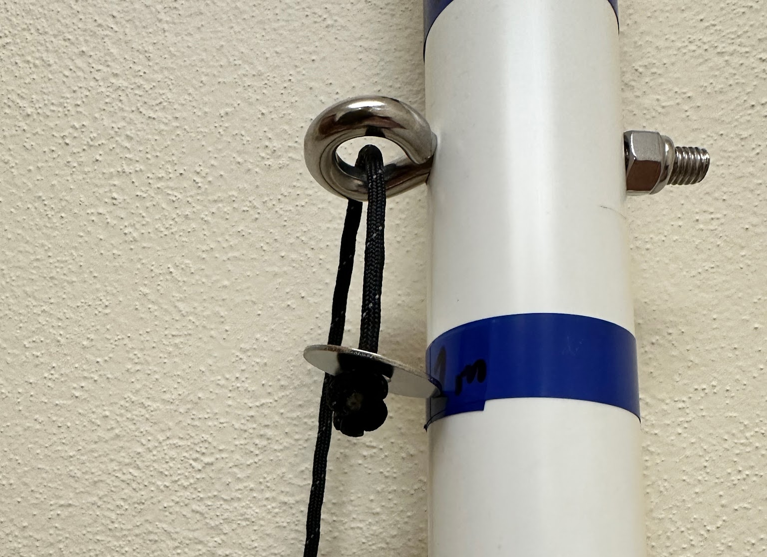
- To unfold and refold the whole frame, you will either release this rope or pull it down respectively.
- Once the rope is put in place, make sure that the eye bolts have their locking nuts put on so they don’t spin around or come undone during use.

Now the entire Under-Ice Licor Frame should be completed.

